Soap Request in SOAP UI

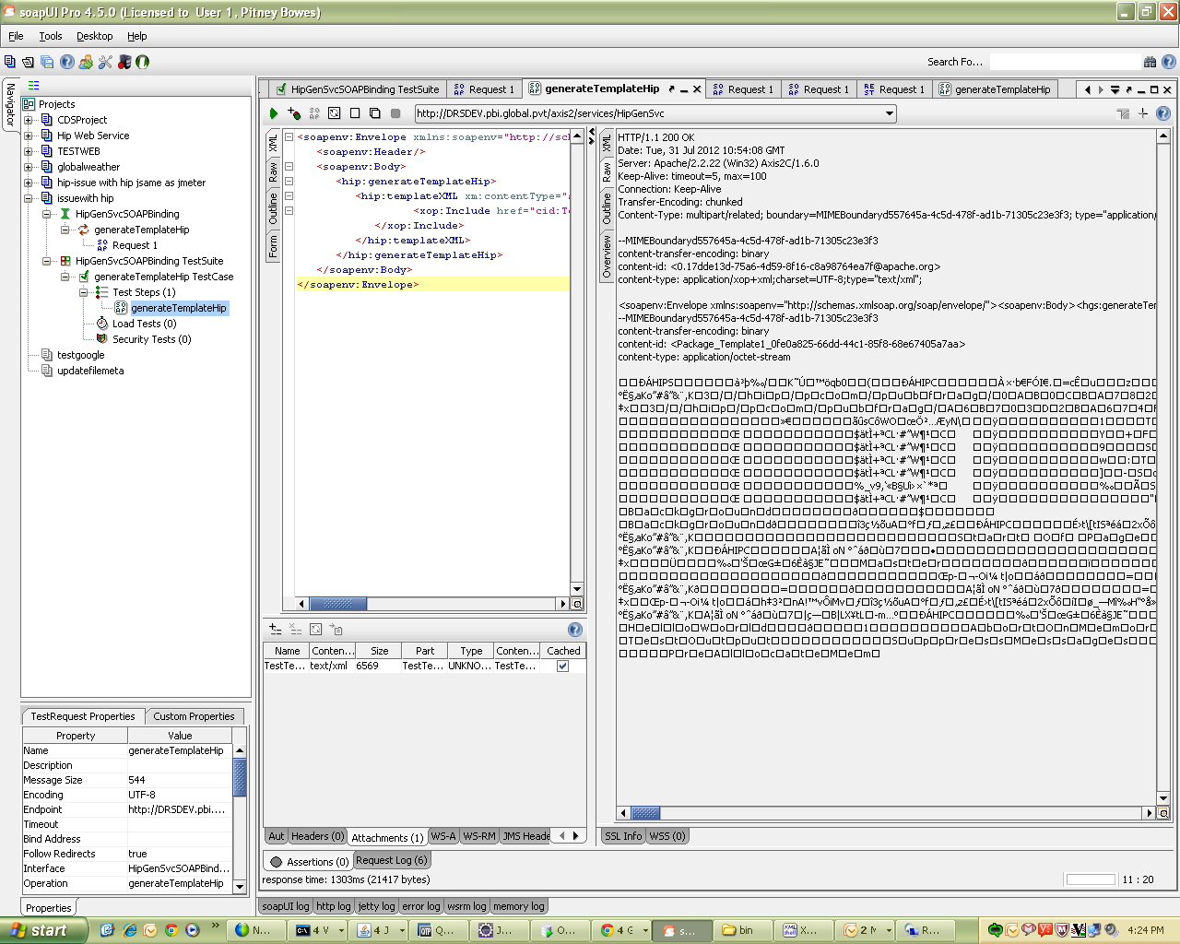

Same soap request created in Jmeter:
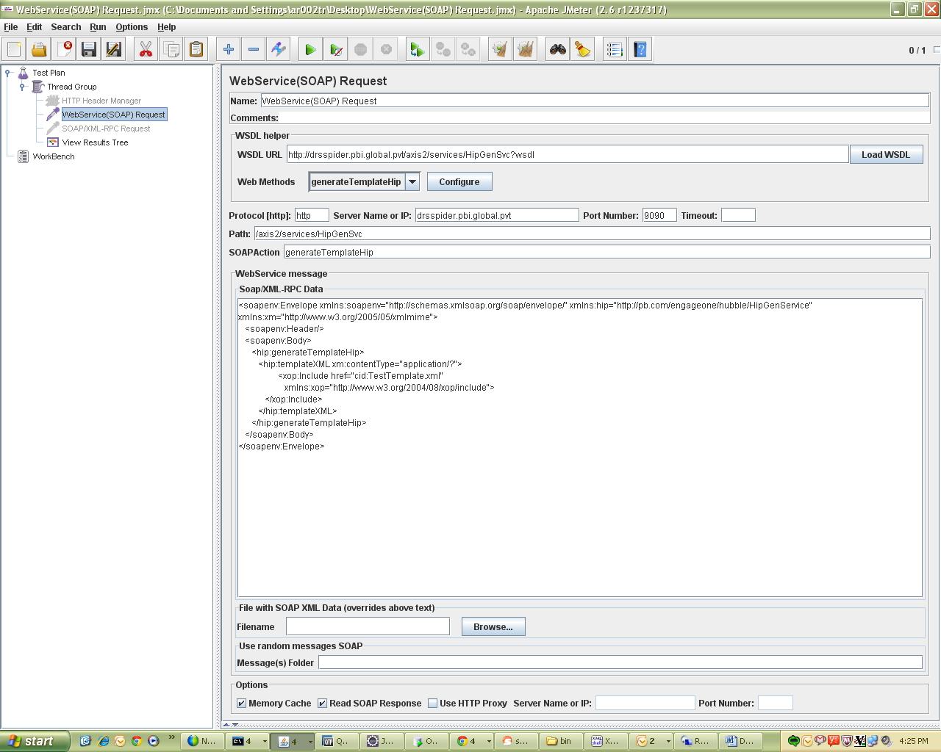

Issue:
Where to attach the file that requires to be sent with Soap request as attachment. For reference see SoapUI request.

